Experiment No.: 9
Title: Implement localStorage and sessionStorage to save user preferences like theme settings.
Software/Tools Required: HTML5, CSS3, JavaScript, VS Code, Google Chrome
Theory: In JavaScript, localStorage and sessionStorage are part of the Web Storage API used to store data in the browser as key-value pairs. localStorage stores data persistently, so it remains available even after closing and reopening the browser, while sessionStorage stores data only for the current browser session and is cleared when the tab is closed. Both provide methods such as setItem(), getItem(), removeItem(), and clear() for managing stored data, and are commonly used for saving preferences such as theme settings, language preferences, and temporary user data.

Output:
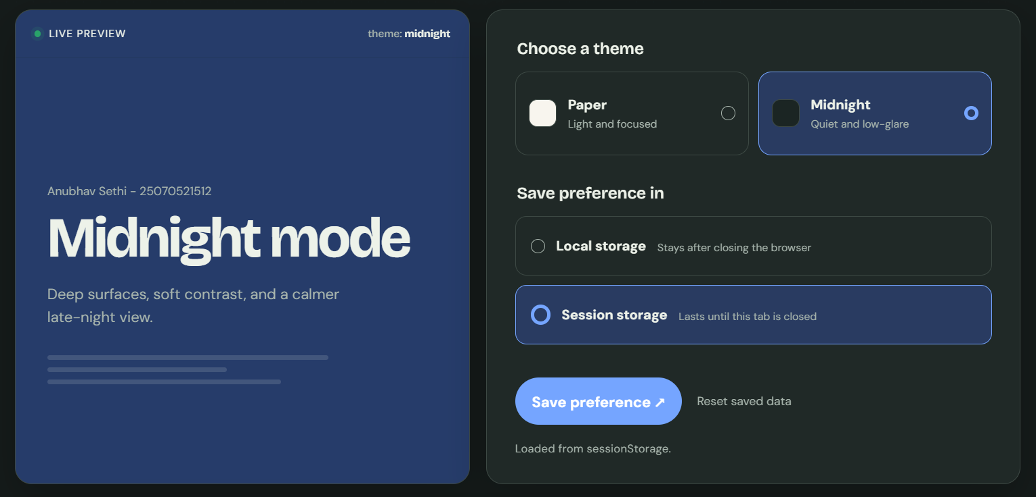
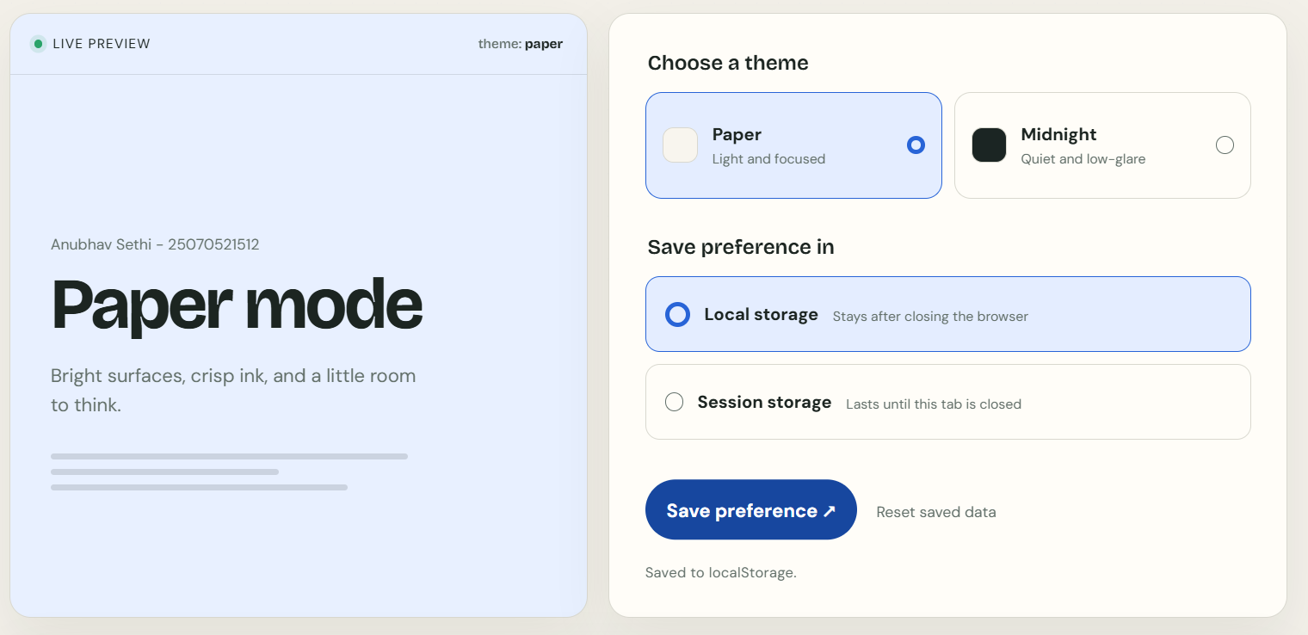
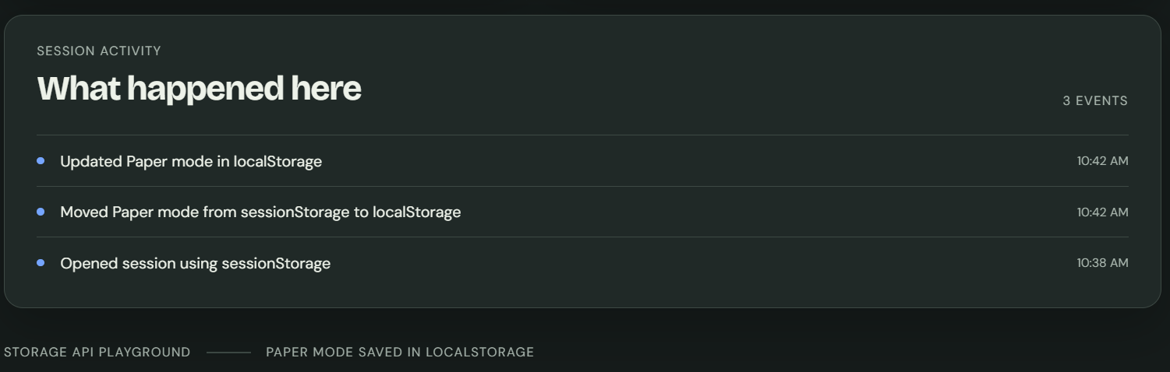

Result: User preferences such as theme settings were successfully stored, retrieved, and managed using JavaScript localStorage and sessionStorage.
Conclusion: Thus, localStorage and sessionStorage can be effectively used in JavaScript to store and manage user preferences, improving the personalized and consistent user experience of web applications.

